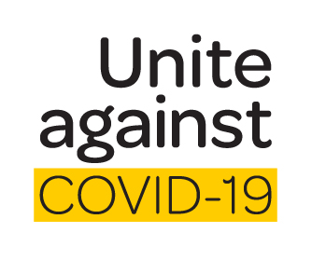
(business logo)

Working Together against COVID-19
Version 2, 24th March 2020

_____(business name)_______ is classified as an essential business as all food and beverage producers and processors, and their supply chains, are deemed to be essential services.
As an employee of an essential service, I ____________(name)_______________ understand that I, with the assistance of my employer, must follow government guidelines to minimise the risk of spreading the virus.
In order to minimise the risks of spreading the virus, I agree that:
- I understand the government regulations around social distancing and will maintain social distance at home, on the way to and from work and while on breaks.
- I understand the government regulations around staying at home and will obey these rules outside of work hours.
- I will follow my employer’s and the government’s advice and maintain strict personal hygiene practices.
- I have been shown the location of face masks and disposable gloves in the workplace, and will use these if I start to feel unwell.
- I will notify my employer and follow the incident reporting system if I start to feel unwell.
- I understand that I must maintain a 2 m distance from other staff members.
- I understand that I must follow my employers guidance on break times in order to reduce contact with other staff.
- I understand that if I am over 70 or at heightened risk of infection, I must identify and isolate myself.
- My employer will endeavour to support me to meet the government requirements and to reduce the risk of spreading COVID-19.

Signed:

_________________
Date

_______________________
Employee

_______________________
Employer

